Turbopump Retrospective

Brendan Morgan

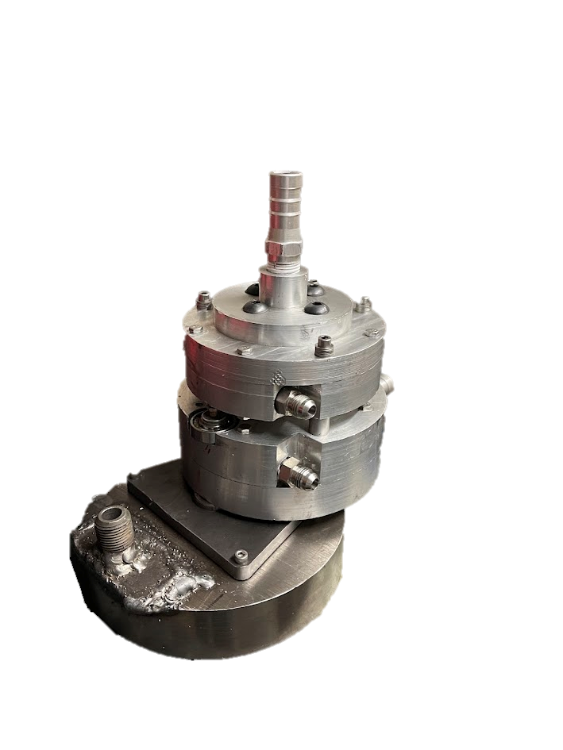

Contents

Summary 3

I. Design 4

Goals 4

Overall Layout 4

Impeller Geometry 6

Profile Curve 7

Blade Curve 8

Inducer Geometry 10

Volute Geometry 12

Turbine 15

Rotor Blade Geometry 16

Rotor Blisk Geometry 17

II. Manufacturing Process 18

Impellers/Inducers 18

Pump Casings 18

Rotor 20

Shafts 21

Turbine Housing 22

III. Testing 24

First Spinflow Test (6/16/2024) 25

Main Issues with First Test 26

Second Spinflow Test (7/3/2024) 28

Sourcing / Tools 29

Helpful People 29

References 29

# Summary

I (Brendan Morgan) designed/analyzed/machined/welded/integrated one complete turbopump, with serious design work beginning in September 2023 and two tests occurring the nights of June 16 and July 7, 2024. I wrote this document for two purposes: one, for myself to remember in detail what I have done so I can expand and improve upon it in future versions; and two, for any others who are interested in doing something similar. I am far from any kind of expert in turbomachinery, but perhaps my approaches, both the successes and failures, might be helpful to someone starting from a similar point as I did to get started and avoid some pitfalls. This report is *far* from exhaustive. I’m mainly covering the most important design decisions, equations, and high level overviews of manufacturing processes.

I’m calling the tests a “spinflow” (turbine spin-up + pump waterflow). The turbine is spun up using pressurized nitrogen gas from bottles, and water flows though both pumps. The nitrogen gas is attempting to simulate a 0.557 kg/s (1017 SCFM) gas flow from a theoretical gas generator. The water is attempting to simulate a 4.5 kg/s flow of liquid oxygen and a 3.8 kg/s flow of 75% ethanol fuel. It is attempting to pressurize the oxidizer outlet to 428 psi and the fuel outlet to 448 psi.

Most design and analysis work can be found on my github and google drive (though many things are quite unpolished and unorganized). Also note there is quite a bit of code and design work on a regeneratively cooled combustion chamber, because the turbopump originally began as part of a larger project to do a full GG cycle. I intend to return to this someday, but for the purposes of this report these sections are not relevant and I won’t be referring to them again.

If anyone does want to do something similar, please take things in this report with a grain of salt, and check against other sources (a few are cited at the end). I am usually reachable on LinkedIn if anyone wants to discuss my experience further to help with their own project.

<https://github.com/BrendanJMorgan/Engine-Development>

<https://drive.google.com/drive/u/0/folders/1xzCn_89ndQEU2PsFcl7RbZjL71s8Y_nX>

# Design

## Goals

* Supply sufficient fuel and oxidizer for a ~3000 lbf thrust engine
* Target outlet pressures of 448 psi for fuel and 428 psi for ox
* Drive pumps using gas turbine, not electric motor
* Optimize for manufacturability and integration. Did not prioritize optimizing for mass, if at all (that can come in later versions).

## Overall Layout

The turbopump has three major sections: an ox pump on the top, a fuel pump in the center, and a gas turbine at the bottom (ordering PPT). The two pumps are on one common shaft, and the turbine on a separate shaft. These two shafts are geared together so the turbine is significantly offset laterally from the pumps. This can all be seen in figure 1 on the following page.

The main alternative to this ordering would be to put the turbine in between the two pumps (ordering PTP). I went back and forth on this for a few weeks but settled on the PPT design because:

1. The turbine could dump exhaust straight to atmosphere, without anything in the way. This eliminates the need for any kind of exit ducting, simplifying manufacturing.
2. It separates the coldest (ox pump) and hottest (turbine) sections as far apart as possible. This simplifies thermal management as opposed to the PTP design which would have an extreme thermal gradient between the turbine and both pumps immediately adjacent to it.
3. Gearing would be much more difficult in a PTP design, as the rotor itself would very likely clash with the pump shaft. This would require either much larger gears to offset the rotor even further laterally, or more complex gearing to put it at an angle. The PPT design allows the rotor to be harmlessly placed below the bottom of the pump shaft.

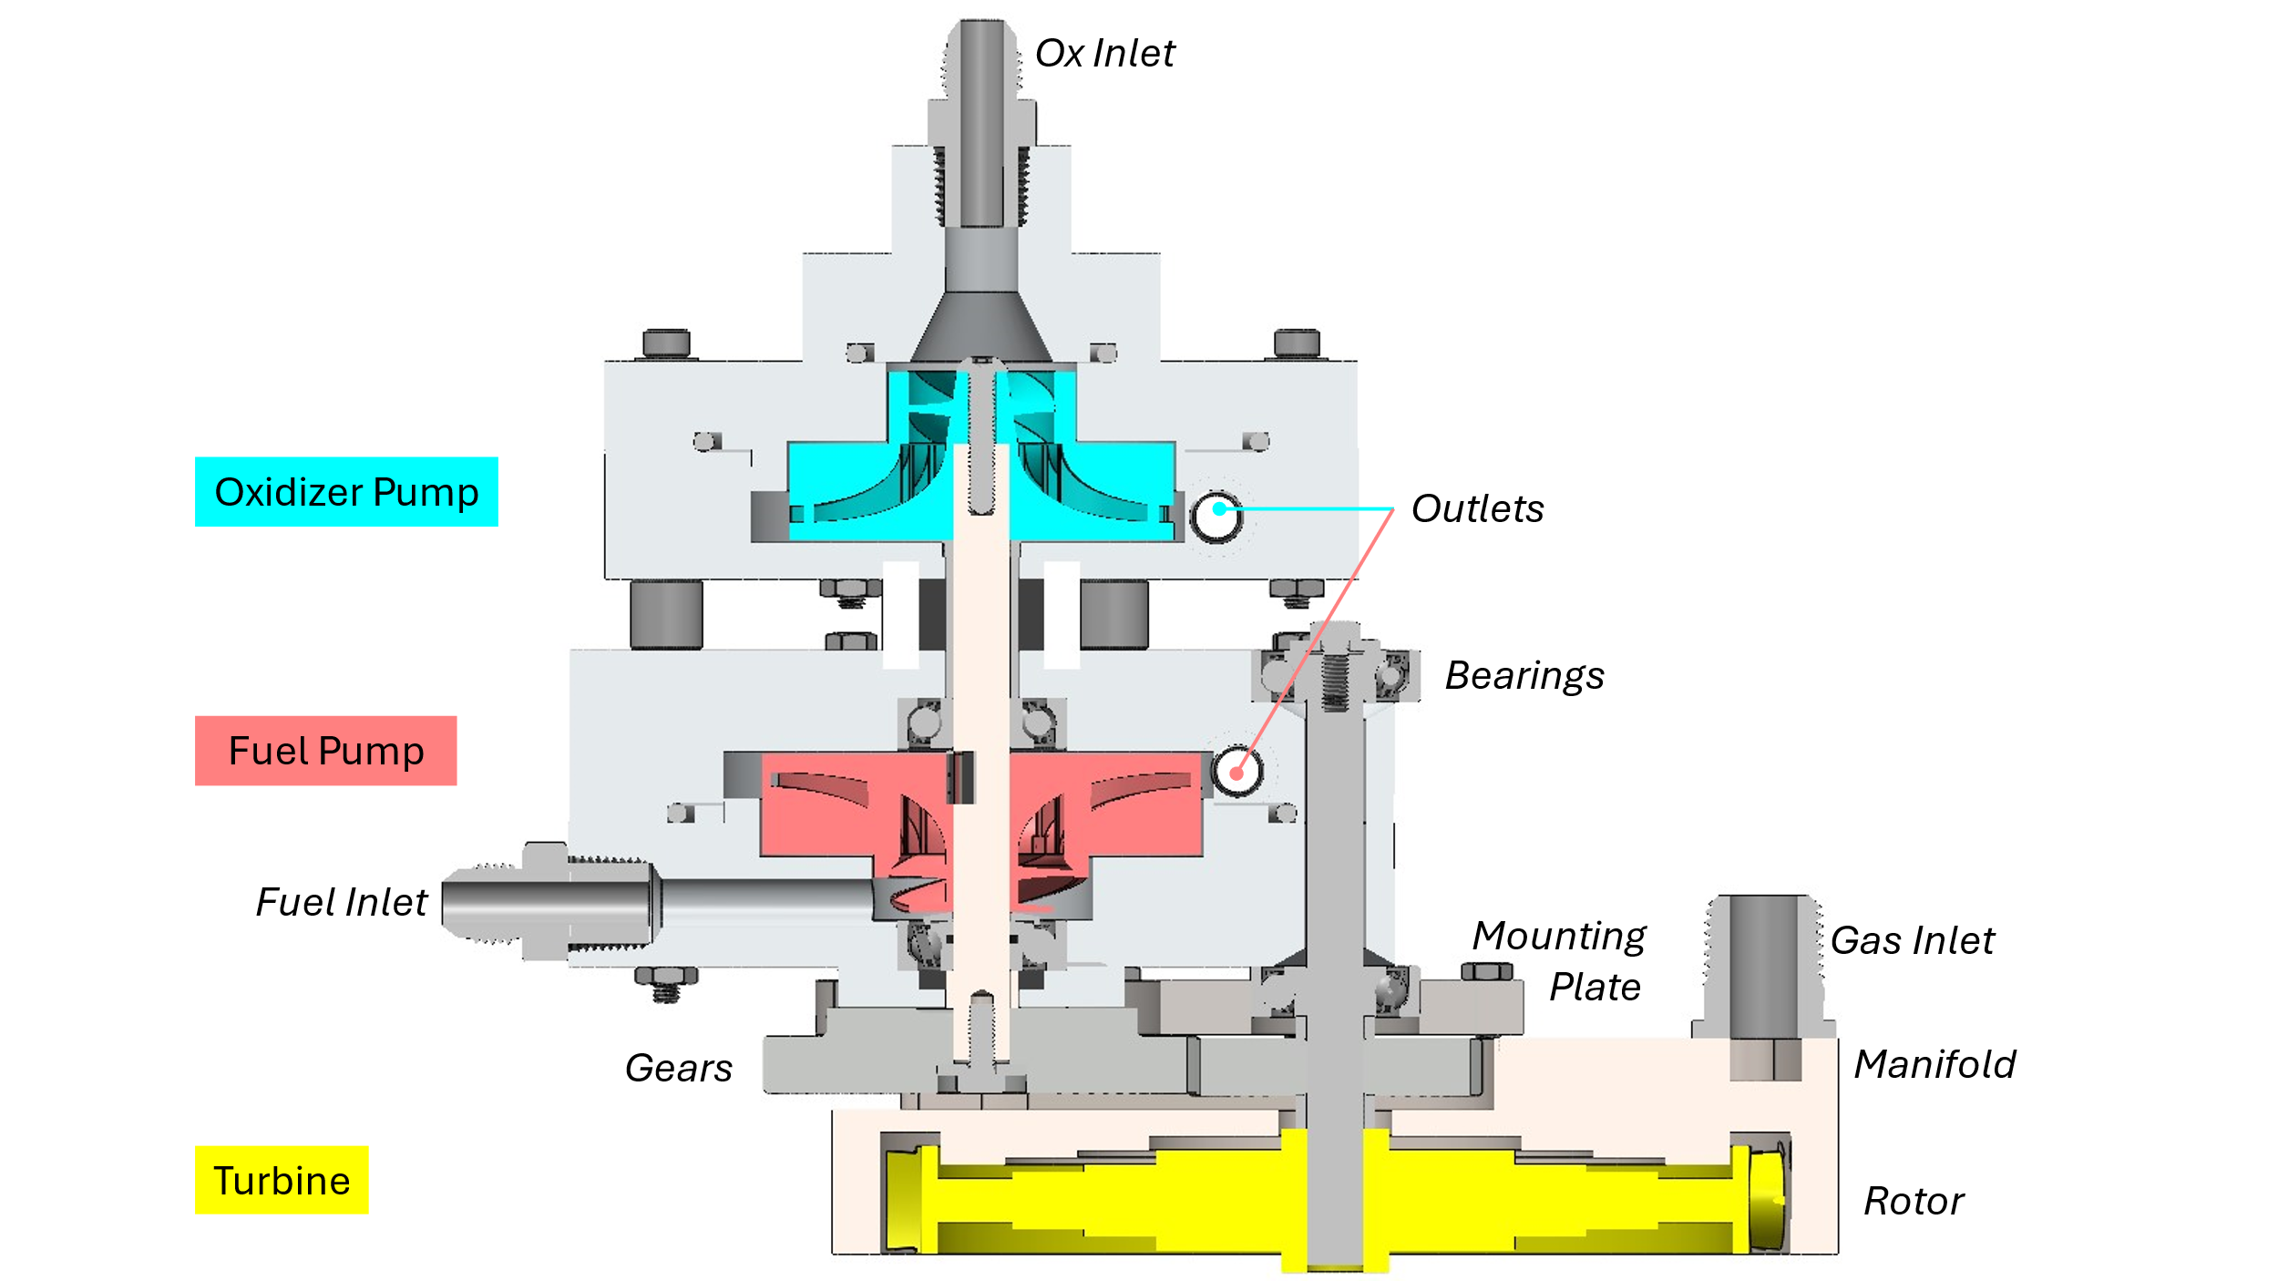

Figure 1: overall cross section of the full turbopump

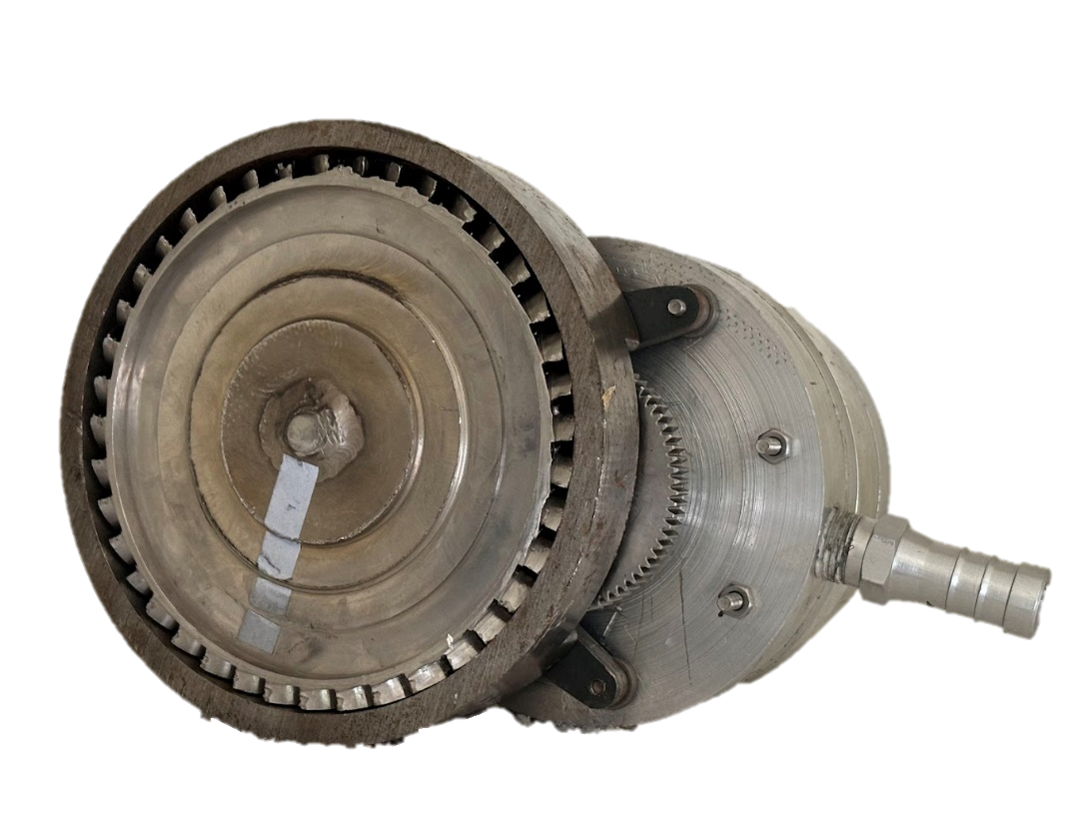

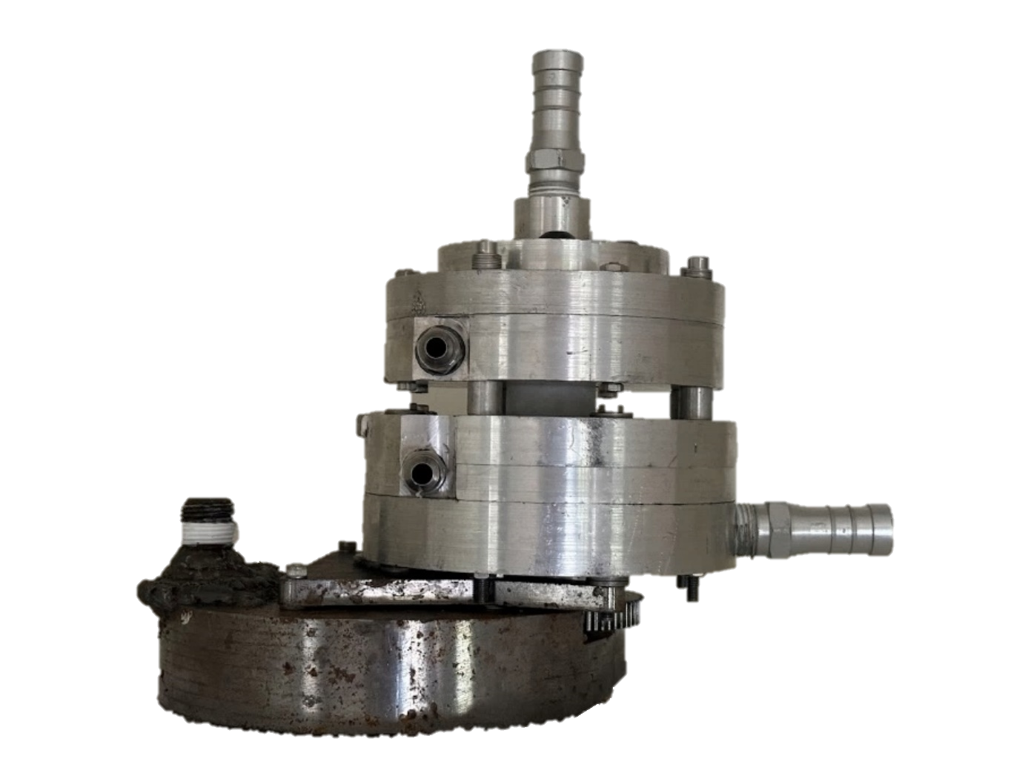



Figure 2: Ox pump contours (left), fuel pump contours (center), turbine rotor contours (right). For scale comparison purposes; more detail given in following sections.

## Impeller Geometry

The impellers are a fully shrouded, centrifugal design with axial inlets that smoothly contour to radial outlets, with smoothly contoured blades that divide the flow into many internal channels. They are designed to rotate at 20,000 rpm; I settled on this value through trial and error in MATLAB. Faster yields an impeller too small and impractical to have 3D printed with decent channels to allow flow through, and faster tends to make the turbine impractical (either too large or needing too high of a gas flow)

The geometry of the contour between the inlet and outlet of the impellers, as well as the geometry of the blades and the volute, were primarily constructed using the pump handbook, especially pages 2.28 – 2.42 (Karassik, Messina, Cooper, & Heald, 2008).

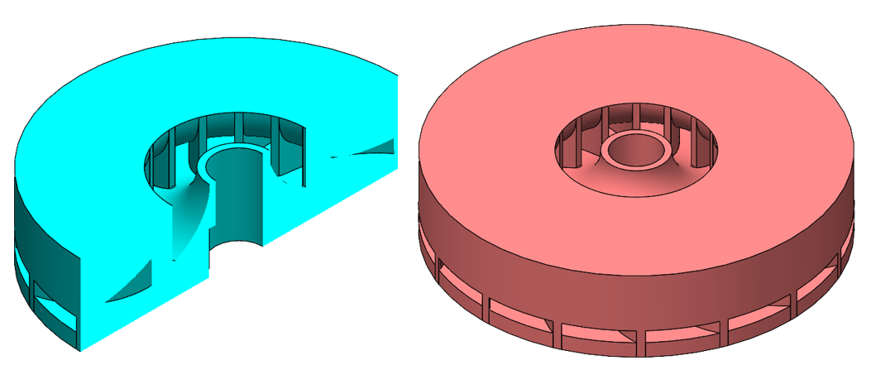

Figure 3: Ox impeller (sectioned) and fuel impeller

Three parameters are established first to size the impeller: the specific speed Ωs, the exit flow coefficient φi, and the head coefficient Ψ. The following are the relationships from pump handbook I used to determine these; equations (2) and (3) are empirical and use SI base units. Q is the volumetric flow rate requirement of the pumped fluid, and ΔH is the head rise requirement (i.e. ΔH = Δp / g). Ω is the pump shaft speed; I chose a value of 20,000 rpm (2094 rad/s). This choice both to met the recommendation for specific speed to be between 0.1 and 0.6 for centrifugal pumps (0.36 and 0.29 for ox and fuel) and outputted reasonable geometry at the end for the profile and blade curves, as well as a reasonably machinable volute geometry.

$$\begin{aligned}Ω_{s}=\frac{Ω\sqrt{Q}}{{\left(gΔH\right)}^{3/4}}\#\left(1\right)\end{aligned}$$

$$\begin{aligned}ϕ_{t}=0.1715\sqrt{Ω_{s}}\#\left(2\right)\end{aligned}$$

$$\begin{aligned}ψ=\frac{0.4}{Ω_{s}^{1/4}}\#\left(3\right)\end{aligned}$$

### Profile Curve

To construct the profile of the impeller, two different curves are generated in MATLAB: first a shroud curve, and then an impeller curve derived from that. The two curves are shown in the figure below.

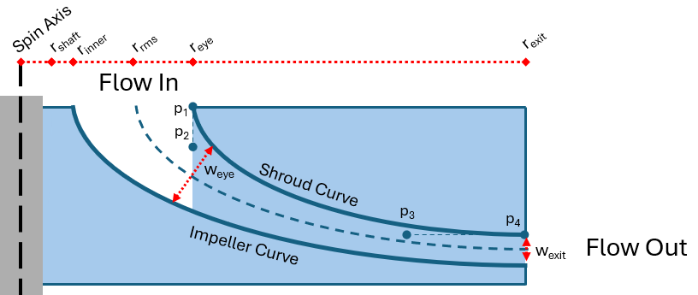

Figure 4: Generic impeller cross section. Fluid flows axially down into the top and radially out the right side.0

There are three key parameters that mostly constrain the shape of the curves: the radius of the eye reye, the radius of the exit r­exit, and the width of the exit wexit. The following three equations show how to calculate these parameters. Equation 1 is transcendental, so reye is found using a MATLAB solver. φe is the eye’s flow coefficient; a range of 0.2 – 0.3 is typical for impellers so I split the difference and assumed a value of 0.25.

$$\begin{aligned}r_{eye}={\left[\frac{Q}{πΩϕ_{e}\left(1-\frac{r_{inner}^{2}}{r_{eye}^{2}}\right)}\right]}^{1/3}\#\left(4\right)\end{aligned}$$

$$\begin{aligned}r_{exit}=\frac{1}{Ω}\sqrt{\frac{gΔH}{ψ}}\#\left(5\right)\end{aligned}$$

$$\begin{aligned}w_{exit}=\frac{Q}{2πΩr_{exit}^{2}ϕϵ}\#\left(6\right)\end{aligned}$$

Much more detail on all this can of course be found in pump handbook. The blockage parameter is calculated from the blade geometry, so for high accuracy the whole impeller + blades scripts are repeated until this converges. The following are some of the key values I settled on for my design, and the actual curve for both impellers.

|  |  |  |
| --- | --- | --- |
|  | Ox Impeller (mm) | Fuel Impeller (mm) |
| rshaft | 5 | 5 |
| rinner | 6.35 | 6.35 |
| reye | 14.29 | 14.49 |
| rexit | 33.91 | 38.76 |
| wexit | 2.87 | 2.57 |



Figure 5: Cross sections of ox impeller (left) and fuel impeller (right). The space between the curves is where fluid flows.

### Blade Curve

The two main constraints on the shape of the blades are the inlet and outlet angles. Figure 6 below shows the geometry of one blade; the rest would be duplicates of this, rotationally symmetric about the pump’s spin axis.

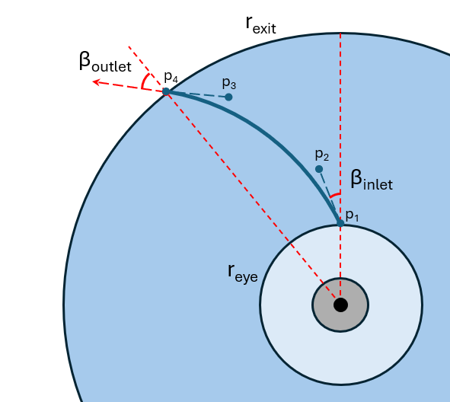

Figure 6: Generic impeller blade profile. Fluid flow radially outwards.

The three equations below show how to find the inlet and outlet angles. ηHY is the combined hydraulic efficiency; equation 8 is Jekat’s formula, an empirical relationship (using SI base units) that accounts for all major sources of fluid inefficiency. μ is the slip factor; the Buseman relationship assumes it is between 0.1 and 0.2 so I split the difference and assumed 0.15. One could do a good bit more calculation to get a more precise slip factor.

$$\begin{aligned}\tan{β_{inlet}}=\frac{U_{inlet}}{V_{inlet}}=\frac{Ω/{r_{eye}}}{Q/{2πr_{eye}b_{eye}}}\#\left(7\right)\end{aligned}$$

$$\begin{aligned}η_{HY}≈1-\frac{0.071}{Q^{0.25}}\#(8)\end{aligned}$$

$$\begin{aligned}\tan{β_{outlet}}=\frac{Q/\left(2πr_{exit}w_{exit}\right)}{Ωr_{exit}\left(1-μ\right)-\frac{gΔH}{η_{HY}Ωr_{exit}}}\#\left(9\right)\end{aligned}$$

The fuel impeller’s blade inlet angle *should* be 76.4o. In actuality because of a MATLAB coding error, the impeller was printed with a blade inlet angle of 88.1o. Similarly, the ox impeller should be at 76.5o but was made to 88.2o. Also, the ox impeller should have had 15 blades but did have 16. The fuel impeller has 15 blades regardless. This may be a factor (but I suspect a rather minor one) in the low head achieved during the spinflow tests.

~

Once sufficiently constrained by the parameters, the actual curves that form the profile contours and the blade contours are all Bezier curves. They are constructed with four control points (I used the minimum possible number), where the inlet and outlet locations serve as a control point (points p1 and p4 in figure 4 & 6) and the other two are at some location along the flow vectors from these locations (points p2 and p3 in figure 4 & 6). The exact distances they are away are left as free parameters for a MATLAB solver, which attempts to minimize the entire curvature of the contour. According to pump handbook, the radius of curvature should ideally never go below half the eye radius to avoid excessive cavitation in the fluid.

The detailed calculations and numerical parameters for everything can be found in the MATLAB scripts impeller.m, and blades.m (themselves subfunctions of pump.m < powerhead.m < main.m) in the project github, linked in the summary section.

The impeller geometry derivation may seem simple, but it probably took me the longest to completely work out in MATLAB compared to all other aspects of the turbopump. Granted this may be because I did it first, but even so getting all the solvers to work correctly and work together is a task that should not be underestimated. Below are the key parameters I settled on for the blades. Actual plots for the blades can be found in figure 2 earlier.

## Inducer Geometry

Both pumps have inducers to combat cavitation. Lox is assumed to be at 1 atm saturation when it enters the pump, so would immediately cavitate inside the impeller without an upstream inducer. The fuel is not so close to cavitation, but nevertheless still requires some NPSH before it reaches the impeller.

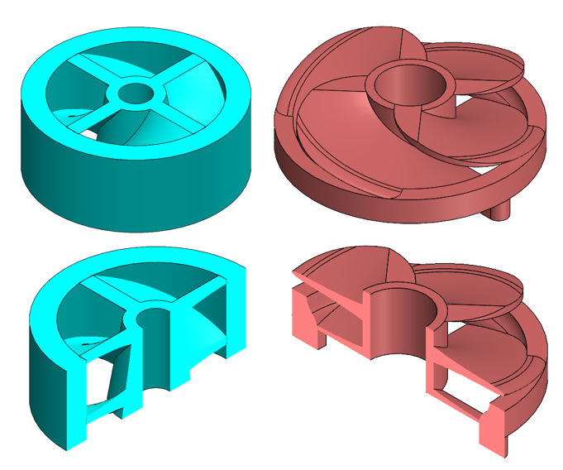

Figure 7: Ox Inducer (left) and fuel inducer (right); sectioned and unsectioned models are the same.

The ox inducer is a shrouded, centrally hubbed design with axial flow through its whole length. Both it and the fuel inducer can be seen in figure 7.

The fuel inducer, while still centrally hubbed, is different in that it accepts inlet flow radially. Over half its length is unshrouded, while the bottom part (closest to its outlet and the impeller) is shrouded. This radial inlet turned out to be a large mistake and is likely the primary reason for anemic flow in the fuel pump during the spinflow test. Essentially, it’s flow coefficient was likely very close to zero. I had designed it this way to make the design more compact and easier to integrate, but a future design should certainly accept flow axially.

There are three main parameters that determine each inducer’s geometry. NPSHSE is net positive suction head, shockless entry: i.e. how much head rise the inducer must induce in the fluid before it reaches the impeller so that it does not cavitate at the impeller entrance (hence “shockless”). The hub to tip ratio ν is a design choice; I used a value of 0.40 for both inducers. I applied an additional factor of 1.5 to the NPSH, as a safety margin.

$$\begin{aligned}{NPSH}_{SE}=1.2Φ_{e}^{2}+\left[0.2334+{\left(\frac{ωr}{128.3}\right)}^{4}\right]\left(Φ_{e}^{2}+1\right)\#\left(10\right)\end{aligned}$$

SS is suction specific speed, a dimensionless parameter that serves as the inducer version of an impeller’s specific speed.

$$\begin{aligned}S_{s}=\frac{nQ^{1/2}}{{\text{NPSH}}^{3/4}}\#\left(11\right)\end{aligned}$$

The optimal flow coefficient φoptimal quantifies the efficiency of the inducer at allowing fluid flow into through it’s entrance and is used in the calculation of an optimal inducer tip radius rtip (that is, the ID of the shroud). The hub to tip ratio ν is a design choice; I used a value of 0.40 for both inducers.

$$\begin{aligned}Φ_{optimal}=\frac{1.3077\sqrt{1-ν^{2}}/S_{s}}{1+\frac{1}{2}\sqrt{1+10.261\left(1-ν^{2}\right)/S_{s}}}\#\left(12\right)\end{aligned}$$

$$\begin{aligned}r_{tip}=1.449{\left[\frac{Q}{\left(1-ν^{2}\right)ΩΦ_{optimal}}\right]}^{1/3}\#\left(13\right)\end{aligned}$$

Blade lead Λ is the distance any individual blade advances per turn; it is a function of blade angle β. This angle is determined via the ratio α/β (flow incidence angle / blade angle); I used a value of 0.35. Lead is in turn used with solidity σ (I used a value of 2.5), to find the minimum required length of the inducer.

$$\begin{aligned}Λ=2πr\tan{β}\#\left(14\right)\end{aligned}$$

$$\begin{aligned}h_{min}=\frac{Λσ}{N}\sin{β}\#\left(15\right)\end{aligned}$$

The following table lists parameters I settled and used for my actual design.

|  |  |  |
| --- | --- | --- |
|  | Ox Inducer | Fuel Inducer |
| NPSH | 22.33 m | 9.00 m |
| Ss | 2.28 | 4.62 |
| rtip | 13.4 mm | 16.5 mm |
| β | 24.8 deg | 14.2 deg |
| Λ | 39.0 mm | 26.3 mm |
| hmin | 10.2 mm | 4.0 mm |

## Volute Geometry

Both pumps use a volute geometry to collect the fluid discharge from the impellers. This is commonly used over a vaned diffuser geometry; it is less sensitive to off design conditions and much easier for me to manufacture in a 3 axis CNC. Each pump casing has two halves that seal together with PTFE O-rings. The volute profile is a spiral, which I intentionally had converge to a square right at the end of its path. This is to somewhat match the circular outlet hole which ultimately transitions to an AN fitting. Shown here are the designs of the four machined pieces.

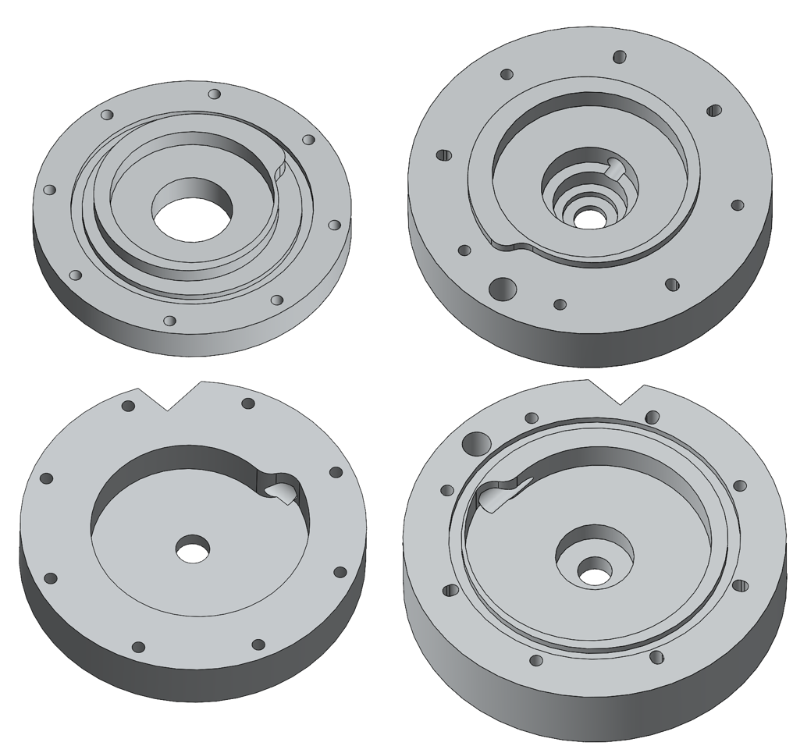

Figure 8: Ox volute (left) and fuel volute (right). The top row are the outboard halves and bottom row are the inboard halves. Ox flow direction is counter-clockwise, fuel flow direction is clockwise.

The following pictures show how these pieces fit together and with the rest of the turbopump assembly. The fuel casing also doubles as what is essentially the structural core of the whole turbopump – it is assembled first during integration, then the lox pump mounted to its top, then the turbine manifold mounted below it with the rotor shaft passing through the outer material of the fuel pump casing. This casing actually holds all four bearings (two for pump shaft and two for turbine shaft); intentionally so because in real operation it would be the only part of the turbopump seeing reasonable temperatures that would not destroy the ball bearings (i.e. freeze or burn off their lubricant).

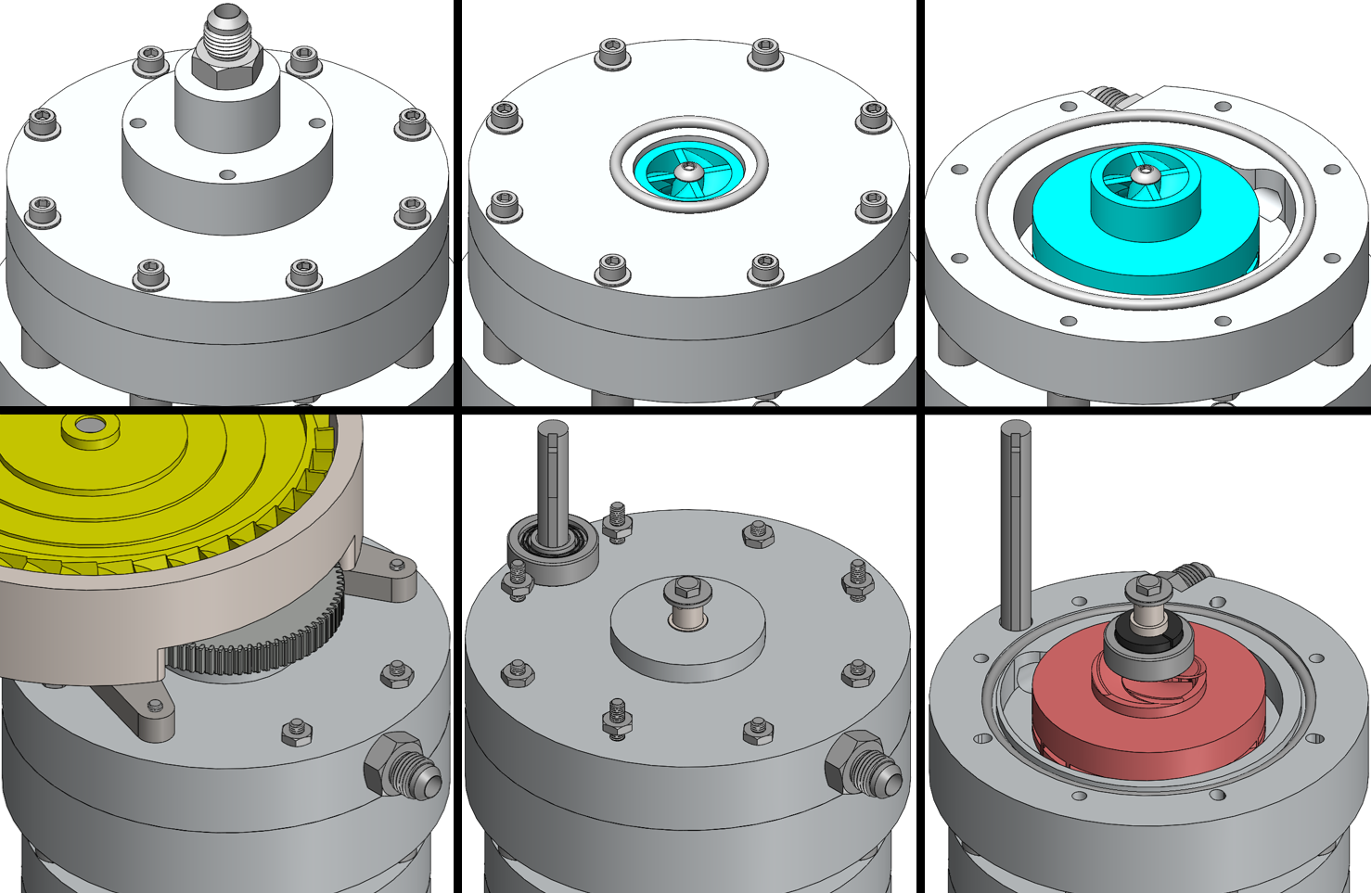

Figure 9: Pump pieces in context of full turbopump assembly. Ox on top, fuel on bottom.

The following ae the actual design values I used for the volute. Some of these values, especially the tongue thickness ttongue, were impractical to realize to any great accuracy (because the tongue doesn’t have a uniform thickness since the outlet is circular) so the value shown is just a target. The rexit is the same as the impeller radii from earlier in the report. Further design guidance on this can be found in pump handbook (pg. 2.40-2.44) and the MATLAB script volute.m.

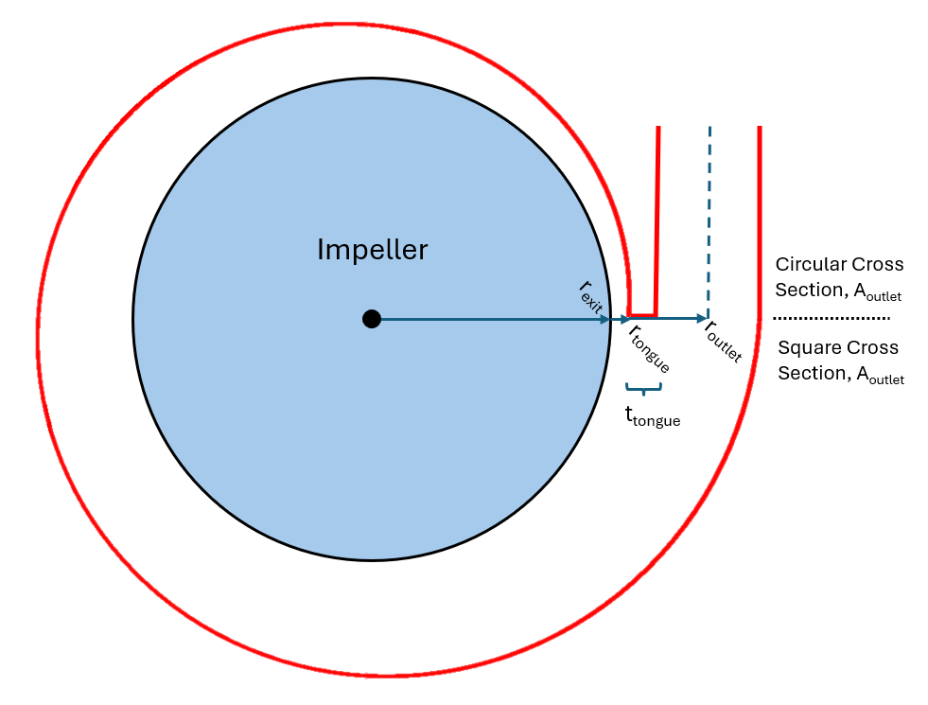

Figure 10: Generic volute profile. The manufactured volutes have a rectangular cross section until the exit, then circular.

|  |  |  |
| --- | --- | --- |
|  | Ox Volute | Fuel Volute |
| rexit | 33.9 mm | 38.8 mm |
| rtongue | 35.9 mm | 41.1 mm |
| ttongue (theoretically) | 0.9 mm | 1.1 mm |
| routlet | 41.5 mm | 46.4 mm |
| Aoutlet ( = hvolute2) | 94.8 mm2 | 81.0 mm2 |
| hvolute | 9.3 mm | 84.7 mm |

## Turbine

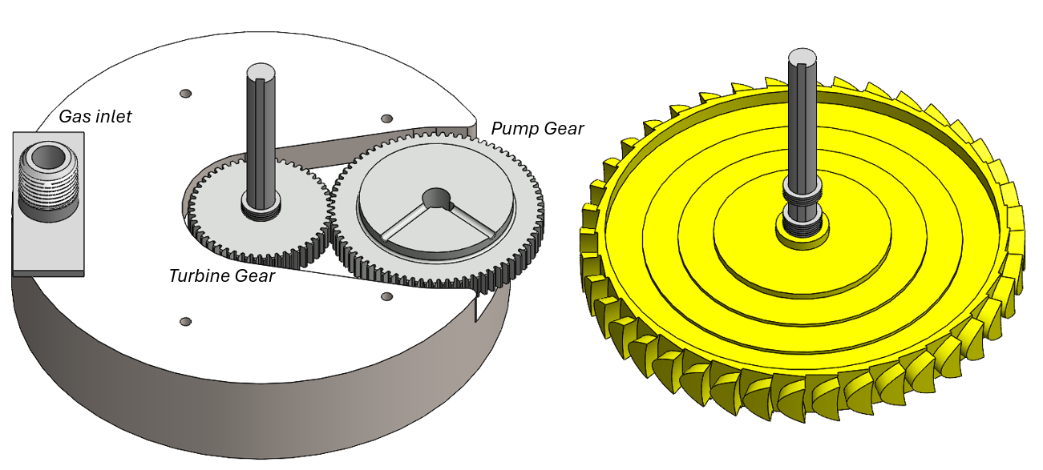

Figure 11: Turbine assembly, with manifold (left); and without, revealing the rotor (right)

The turbine is an impulse design, with an unshrouded 304 stainless steel rotor placed inside a carbon steel manifold. The turbine shaft is designed to spin at 30,000 rpm, so it is geared off at a 3:2 ratio from the pump shaft which is designed to spin at 20,000 rpm. I chose this turbine speed because it was the fastest that I could support with readily available McMaster angular contact bearings. There is a tradeoff between turbine speed, its pitchline radius (i.e. the radius of the blades’ centerline), and the required gas flowrate. I was interested in minimizing radius, to cut down machining time/complexity and stick to more readily available stock on both the rotor and manifold; and in minimizing gas flow simply because nitrogen gas bottles can only supply so much during a spinflow test.

### Rotor Blade Geometry

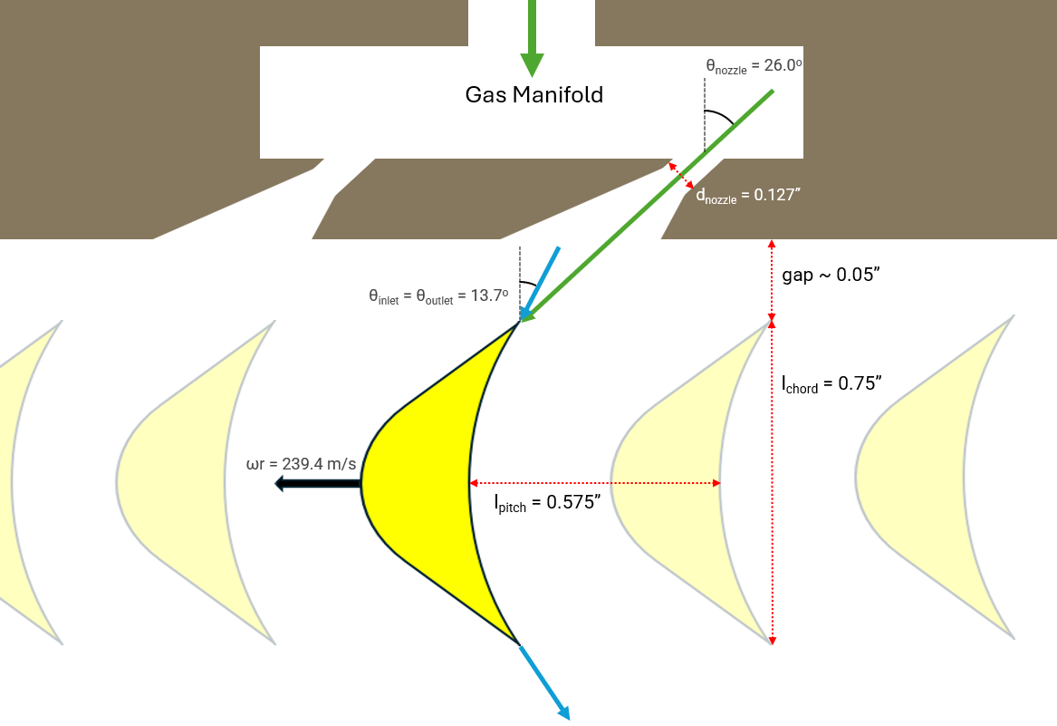

Figure 12: gas flowpath through rotor blades. Green is flow in a stationary frame of reference while blue is flow in a corotatin frame of reference with the rotor.

The purpose of the blades is to redirect the incoming flow from the manifold nozzles, which imparts an impulse to the blades themselves and drives the rotor in a clockwise direction. The intention is that there is no post-swirl for maximum efficiency; i.e., in a stationary frame of reference, the gas exits the rotor moving straight down, not diagonally. In the relative (corotating) frame of the blades this means the flow has the same incoming and outgoing lateral speed, just in opposite directions. For this reason the incoming and outgong blade angles are identical, making the blades symmetric as shown in the above figure.

A principal concern in designinig the turbine is knowing how much power it must acutally supply to meet the needs of the two pumps. For this a full efficiency needs to be calculated, which includes multiple inefficiency coefficients. Namely expansion energy loss (φ), which is a function of blade deflection angle; an empirical curve can be found in the NASA turbines paper cited at the end. The kinetic energy loss coefficient (Ψ), is also a direct function of φ. Ci is the incidence angle loss coefficient, and Cm is the mach-number coefficient; empirical data for both of which can be found in the NASA turbines paper as well.

$$\begin{aligned}Δh_{e}=Δh_{es}+Δh_{ev}=Δh_{s}⋅ϕ^{2}+Δh_{v}⋅ψ^{2}⋅C_{i}⋅C_{m}\#\left(16\right)\end{aligned}$$

$$\begin{aligned}ψ^{2}=2ϕ^{2}-1\#\left(17\right)\end{aligned}$$

### Rotor Blisk Geometry

The principal structural concern of the rotor is centrifugal stress – i.e. its burst speed. I quickly found that torque on the blades had negligible stresses comparatively, even if the blades were significantly longer.

The rotor has a stepped profile to survive the centrifugal stress. I.e., the amount of mass far from the axis is minimized while still being thick enough to support the ‘weight’ of the blades along the rim. A shrouded rotor is best from a fluid efficiency perspective, but I realized after many iterative attempts that this was untenable from a structural perspective – it adds too much mass very far from the central axis.

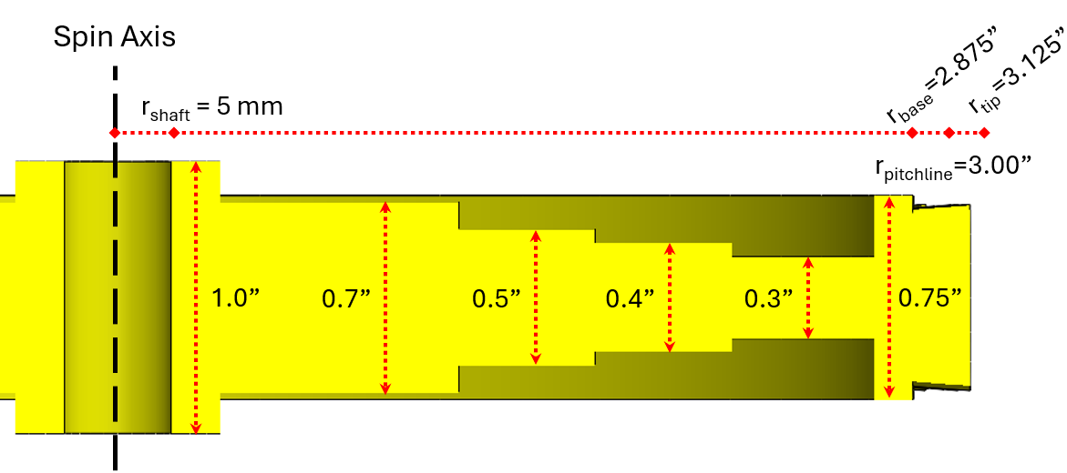

Figure 12: Rotor stepped profile

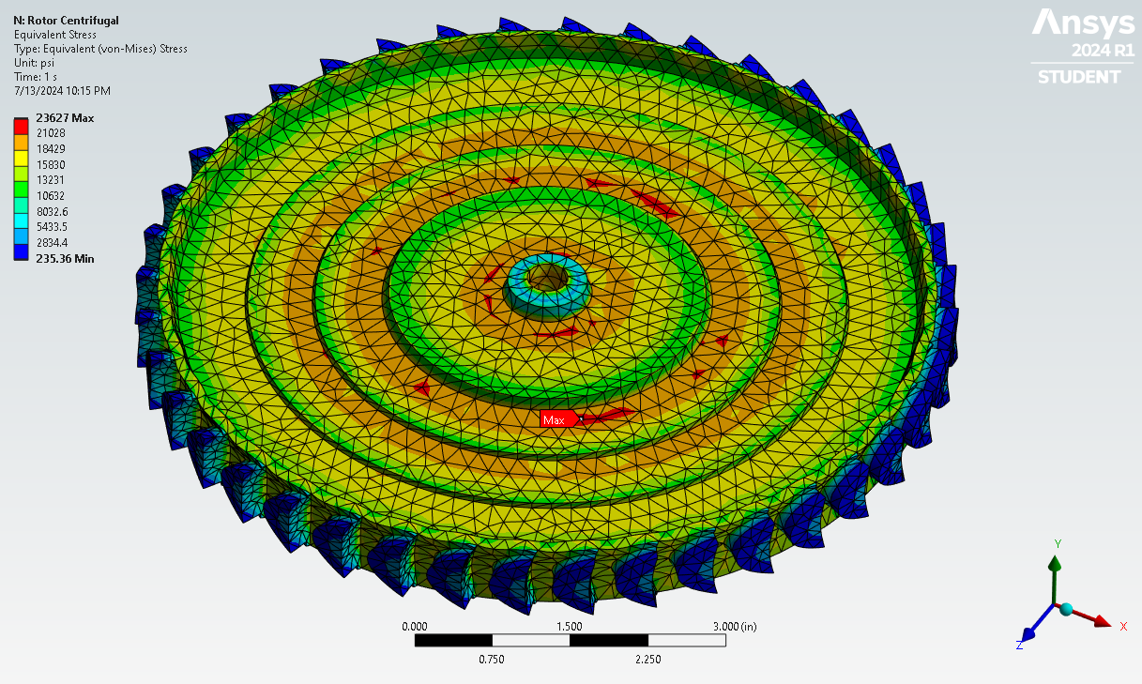

Figure 13: Stress on the rotor blisk. 304 stainless has an ultimate strength of approximately 39 ksi at 1300 F.

# Manufacturing Process

## Impellers/Inducers

The two impellers and the two inducers were 3D printed out of aluminum using Craftcloud.com. I elected the glass blasting option but I don’t think it made much difference. The top and bottom faces of the impellers were faced off with a lathe to both increase clearance against the casing and to achieve a smoother finish.

The two impellers have a 3 mm keyway, about 10 mm long and toleranced using the ISO 286 specification. I had no issues fitting in machine keys with a snug fit that could relatively easily be assembled and disassembled by hand.

The inducers do not have keyways, simply because they would have been two deep for the geometry and made a hole rather than a groove. The fuel side inducer has two convex features on its outer shroud that nested into matching concave features on the impeller. The ox side inducer has an axial clearance hole for a 10-32 fastener that screwed into a tapped hole on the end of the pump shaft. The pump shaft is intentionally spun counter-clockwise (from the viewpoint of looking down upon the ox pump) so that the fluid reaction torque could only tighten, not loosen, this fastener.

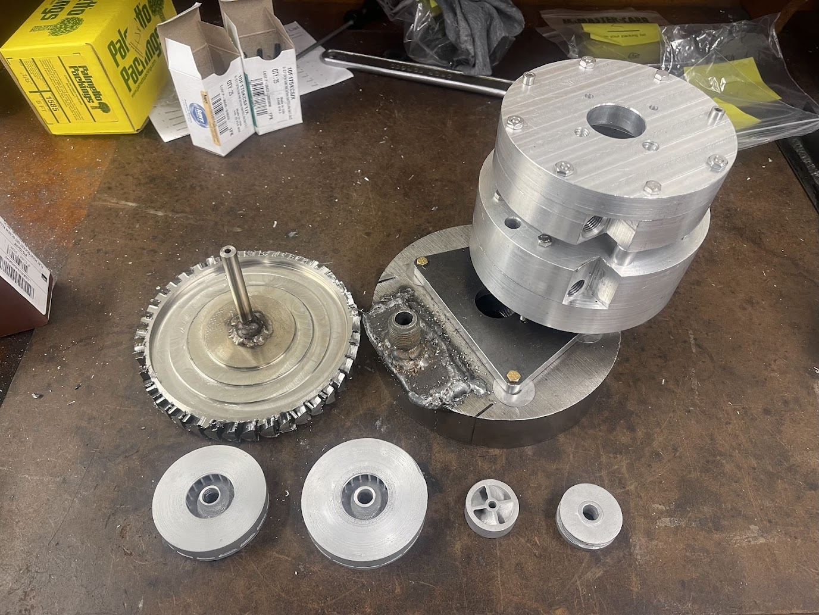

## Pump Casings

The ox pump has three pieces to its casing: an inboard half with an inset cavity containing the impeller and a volute channel; an upper half that mates to this; and an inlet piece on top of the upper half. The fuel pump has just two pieces: a similar inboard and outboard half (the fuel inlet is a feature integral to the outboard half) All of these pieces are 6061 aluminum, and all but one were mostly machined on a 3 axis CNC mill, then some features added on a manual lathe and/or mill. The ox inlet was done only on a manual lathe and mill.

Both halves of each pump were CNC milled out of 6” OD stock, with a square cross section spiraling outwards from the exits of the impeller channels. The ox volute was later lathed down to a final OD of 5.25” and the fuel volute to 5.75”. The fuel pump was made larger to accommodate a slightly larger impeller and volute (mostly owing to ethanol’s lower density relative to liquid oxygen; see design section). It is also larger to accommodate the turbine shaft and one of its associated bearings; the fuel pump essentially serves as the structural core for the whole turbopump. The CNC also drilled eight axial holes to fasten the halves both to each other and to the other pump and turbine manifold.

After the CNC operations, both inboard halves had a slot milled out and holes drilled to serve as the outlet. Threads were tapped to accommodate a -6 AN fitting. The fuel outboard half also had radial holes drilled to serve as the inlet, directly impinging onto the side of the fuel inducer, and threads tapped to accommodate a ½” NPT fitting. In hindsight the placement of this radial hole was a mistake and is probably most responsible for the terrible fuel pump performance relative to the ox pump. The inlet should have been designed to provide roughly axial flow onto the inducer instead; this is discussed in more detail in the test discussion section.

The ox outboard half had four holes tapped on its exterior face to mount the inlet piece. The inlet piece itself was lathed and drilled from 3” OD stock, with a ½” NPT tapped hole leading straight (axially) into a conical expanding section which led the fluid to impinge axially onto the ox impeller. In hindsight integration would have been simpler if the inlet piece was eliminated and instead the ox outboard half machined from a larger piece of stock to accommodate an integral inlet.

1/8” O-ring grooves (face seal) were also machined into the fuel inboard half, the ox outboard half, and the ox inlet. The MIL-G-5514G specification was used for tolerancing these. Grooves for the PTFE interpump spacer were lathed into the exterior faces of both inboard halves.

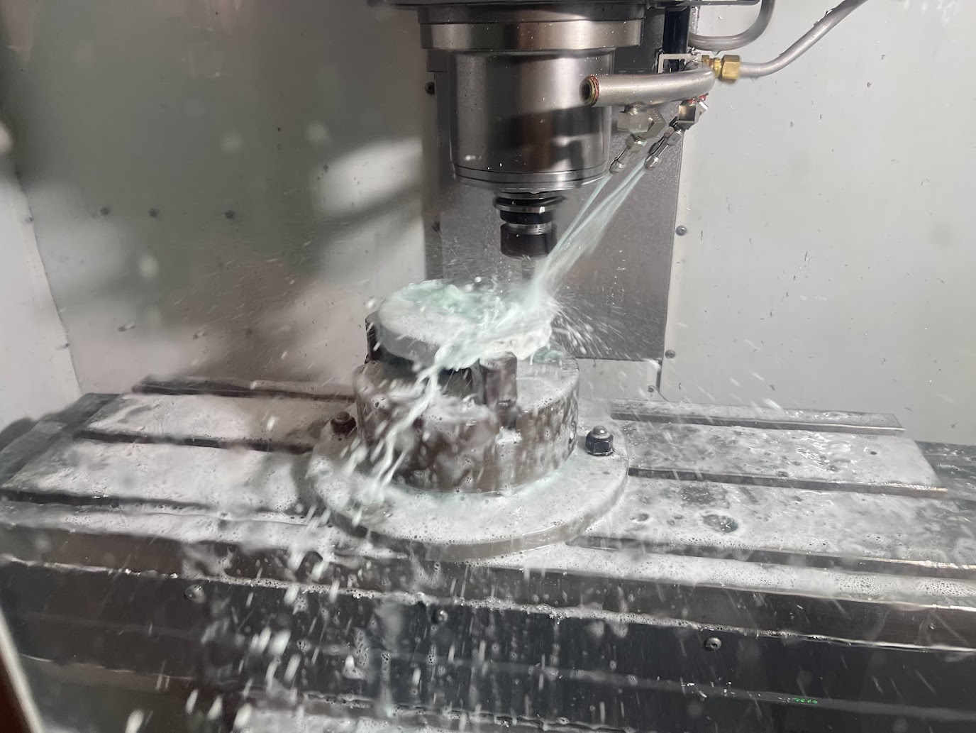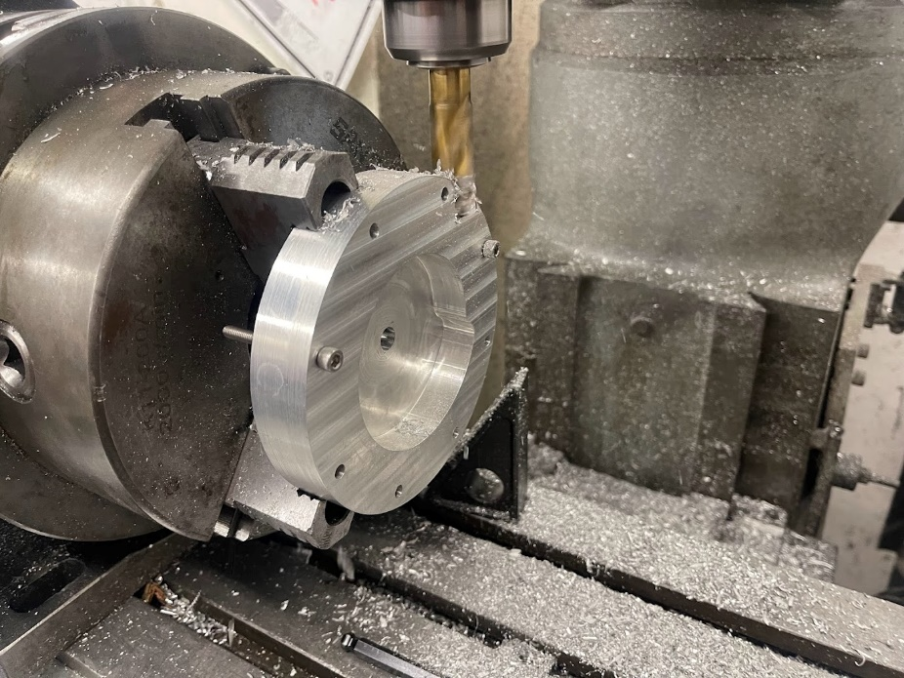

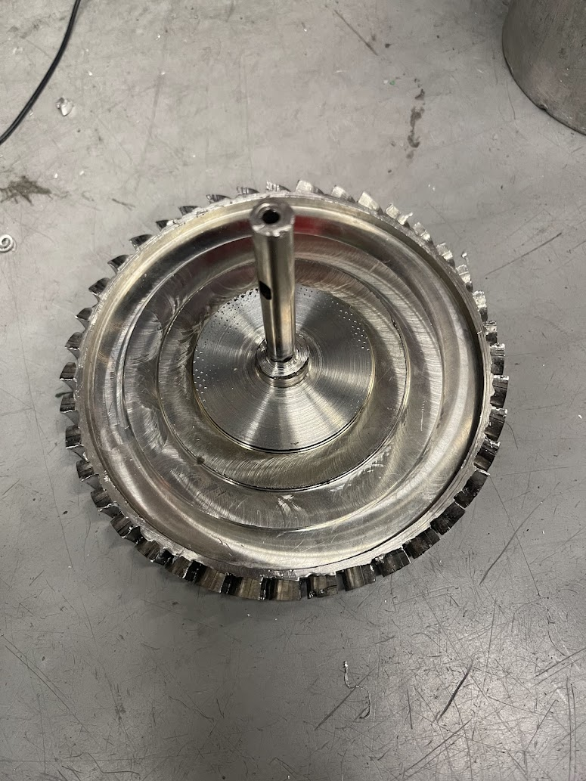

## Rotor

The turbine rotor is a single-stage, impulse driven design. It was made on a 3 axis CNC mill from 304 stainless steel. The main disk has a stepped thickness (thickest at center) to survive the centrifugal stress (more detail in analysis section). Two CNC operations were done on each face of the stock to form the main disk.

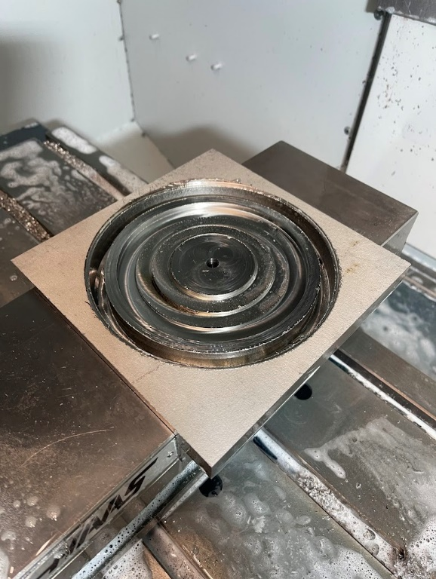

After that, the disk was mounted in a rotary table (oriented with disc normal along CNC y-axis), and then each blade milled out with a 2 mm endmill. I broke more than one endmill by milling too aggressively; but ultimately settled on a federate of 5 ipm that seemed to work well. Each blade was an approximately 12 minute operation. The rotary table was manually rotated 9 degrees between each blade operation for a total of 40 blade cuts; I did this over the course of 3 days.

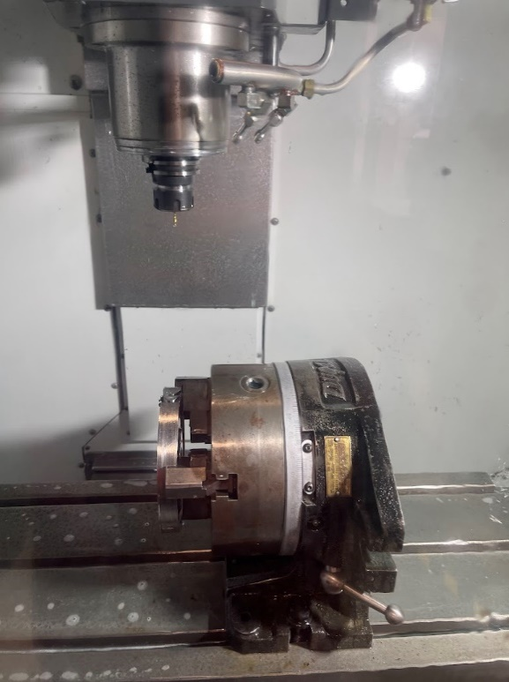 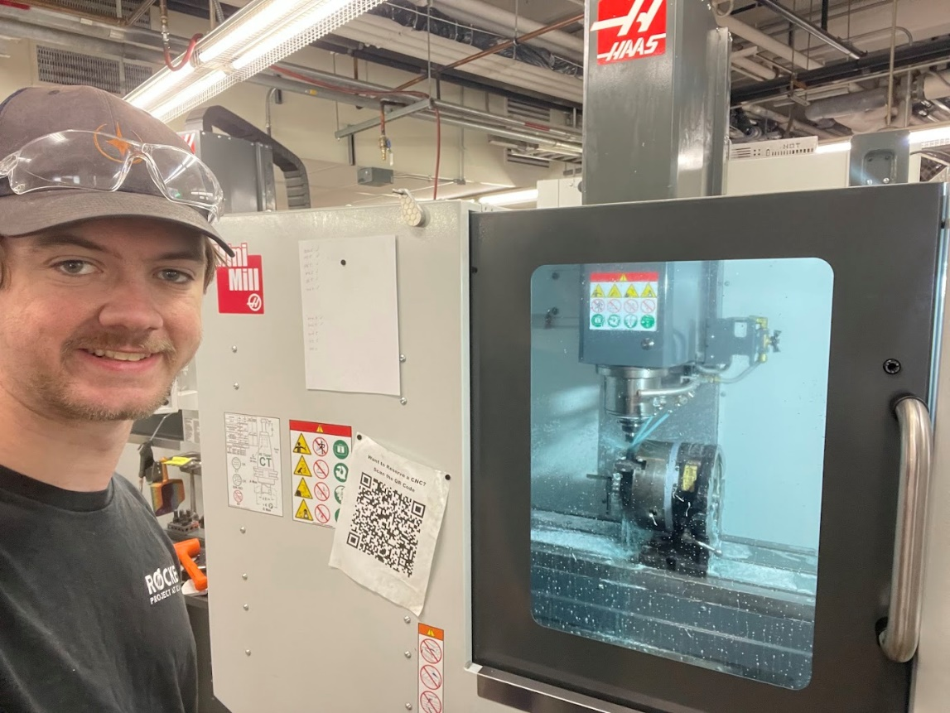

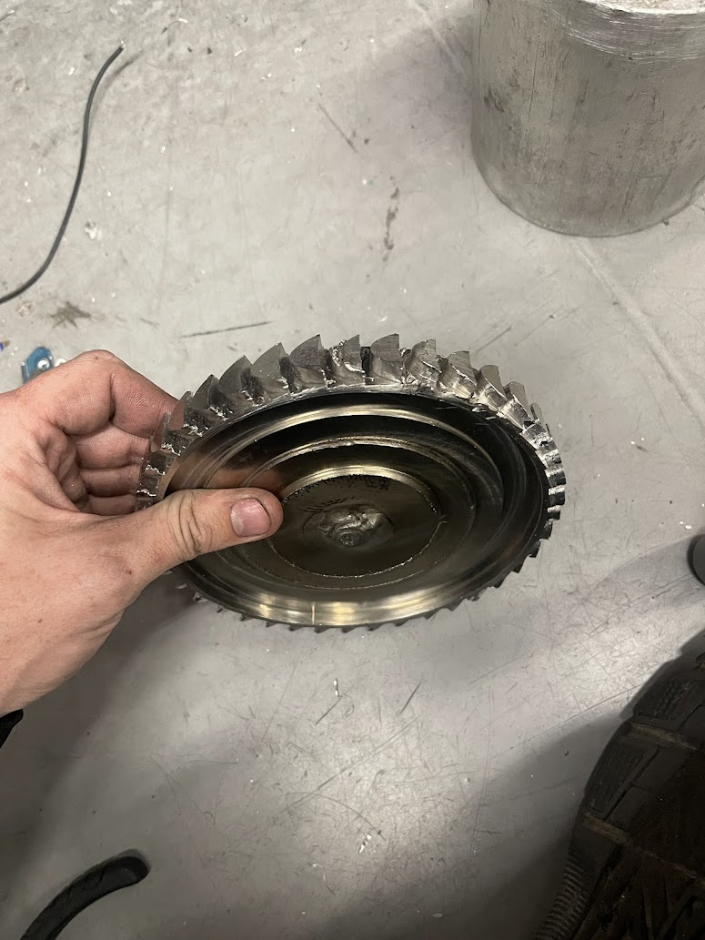

## Shafts

There are two shafts: a pump shaft and a rotor shaft. Both are 10 mm OD, 303 stainless steel rotary shafts from McMaster Carr. Keyways were manually added using a mill. The pump shaft has two 3 mm keyways (for the impellers) and one 4 mm keyways (for the pump gear). The turbine shaft has a single 4 mm keyway (for the turbine gear). These were milled using 3 and 4 mm endmills, with about 0.020” passes for the 3 mm and about 0.050” passes for the 4 mm, with a <1 ipm feed rate and copious manually applied coolant. Keyways were toleranced using the ISO 286 spec.

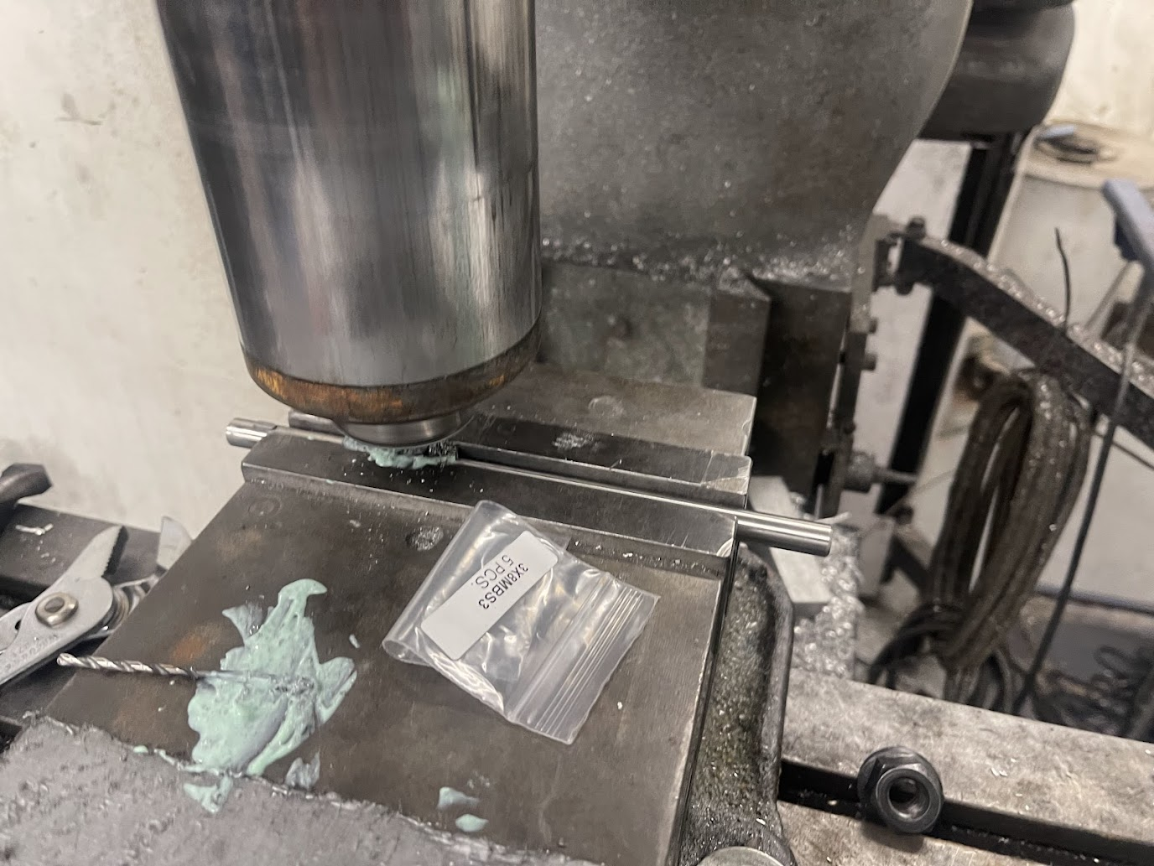

In hindsight I would have made all keyways 4 mm and likely made the shaft 12 mm, because of the higher availability of parts (gears, bearings) that interface with that larger size.

The turbine shaft was welded to the rotor. The shaft was 303 stainless and the rotor 304 stainless. The process was TIG with ER308L filler wire. The shaft was inserted through the rotor’s central hole (press fit), sticking out about 0.1” or so on the rotor’s lower side. The welds were essentially lap joints, continuous around the circumference of the shaft, on both sides of the rotor.

More care should have been taken to ensure the shaft was precisely perpendicular to the face of the rotor. I should have created a jig setup. For external reasons I had very little time and notice to do the welding, so I made do as best I could with simple clamps.

Turbine Housing

The turbine housing contains the gas manifold which feeds off N2 bottles in a spinflow or a GG in a hotfire. It also serves as a shroud around the rotor blades and as a structural mounting point for the primary bracket. The housing was mostly CNC machined from a single disc of 4140 cold-rolled steel, 7” OD by 1” thick. This took many hours with a a feedrate of ~5 ipm.

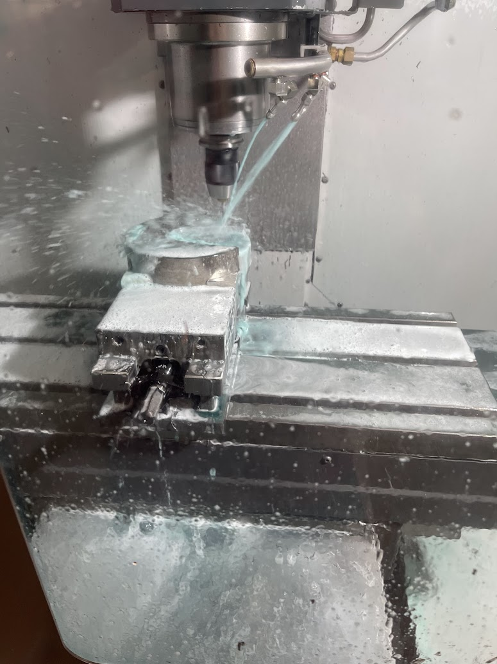

The gas manifold feature had a 1/8” mild steel plate welded on top to create a fully enclosed space. The process used was MIG; I would have preferred to use TIG for a cleaner weld, but a MIG was the only machine available to me the day I needed to finish this. I then welded a ½” pipe nipple vertically to it, and drilled out the central hole through the plate to create an inlet for GG gas.

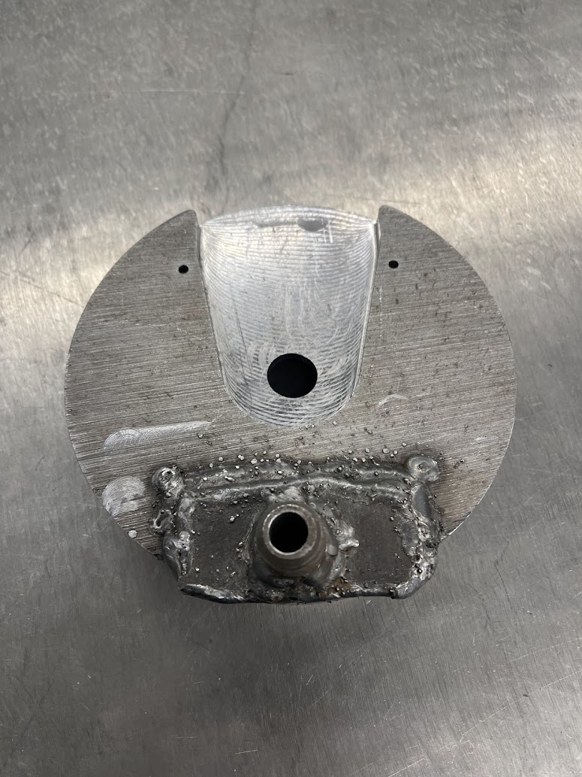

Three slanted holes were then drilled into the enclosed space, from the other side, and were then ground somewhat conically. This was done on a manual mill, with the head tilted by 26 degrees drilling down onto the housing which was mounted flat on a rotary table (so I could rotate between the three hole locations). These created the choked flow nozzles from which gas would leave supersonically and impinge on the rotor blades, imparting an impulse (hence the name “impulse driven rotor”). Later on, I realized that my N2 gas flow requirements had changed and it would more optimally have just two holes. So I blocked up the central hole by quite forcefully hammering a wood screw into it; I used a wood screw because it has large prominent threads that could deform into the hole to block it up.

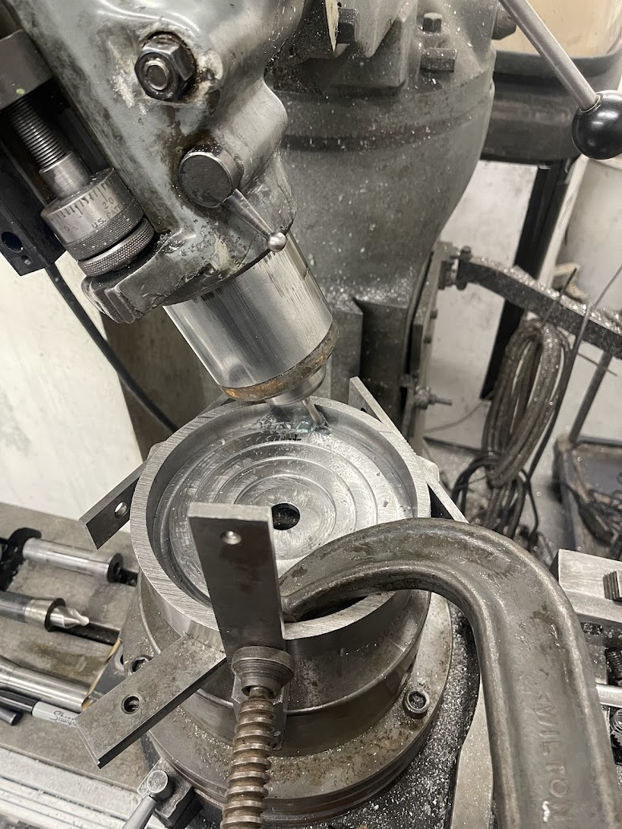 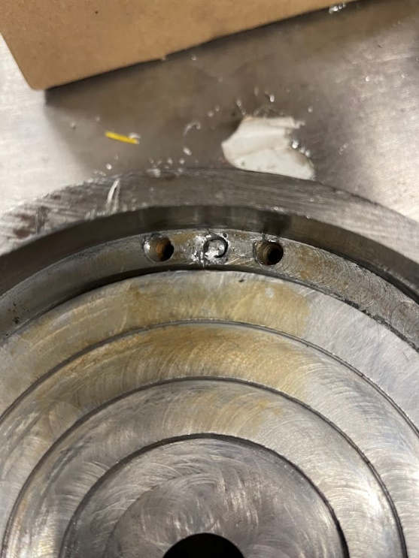

# Testing

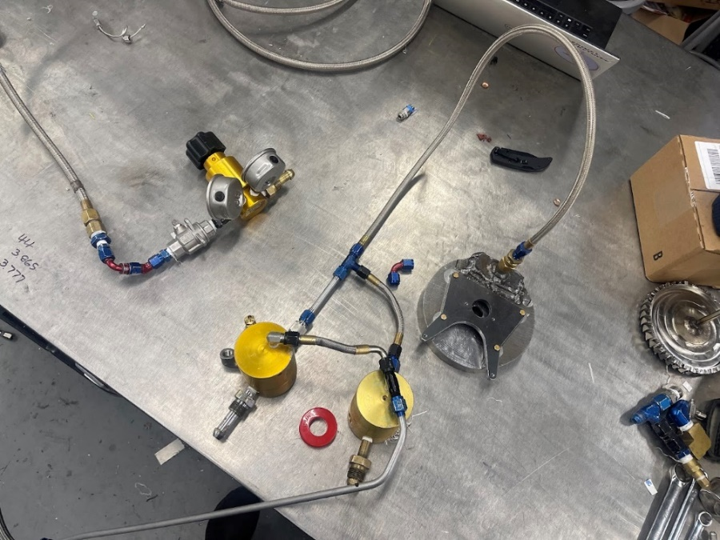

Nitrogen feed system. This is the only part of the project designed by someone else; thank you to Roni Margousi.

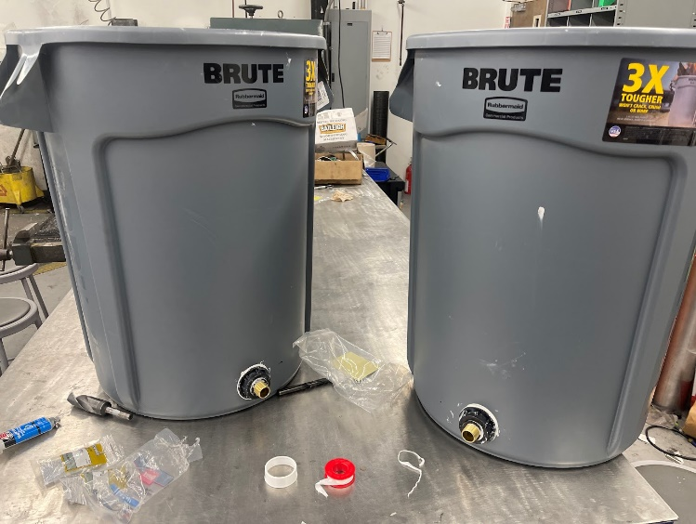

Two highly sophisticated water tanks for the test (one for each pump).

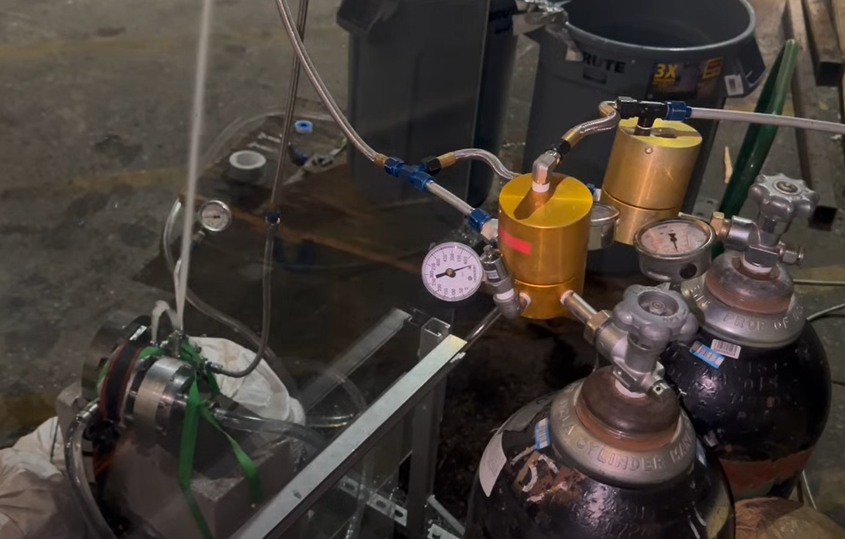

The feed system works by feeding off two separate nitrogen k-bottles to reach the required 1017 SCFM gas flow rate. There are two dome loaded pressure regulators, one on each bottle. A third bottle has a pilot regulator on it and is used to set the pressure of the dome regulators that are actually providing gas flow for the turbine. Nitrogen flows through flex hoses into the welded inlet piece of the turbine manifold.

Water for the is supplied from two garbage cans that I converted into large reservoirs (I bought them brand new; no trash FOD)

## First Spinflow Test (6/16/2024)

*Wins and Strong Points*

* The fact that it worked at all is surprising to me. I am stoked by the results of the test even though it significantly underperformed compared to the design goals.
* Little to no noticeable water leakage around any of the seals, barring a little dribbling on one side of the fuel pump. This was expected and discussed later.
* No noticeable structural damage on the pumps or turbine.
* Packing seals performed well as far as I can tell, though they should be inspected when the turbopump is taken apart later.
* Turbine seemed pretty balanced for the relatively minimal work I put in to doing so.

### Main Issues with First Test

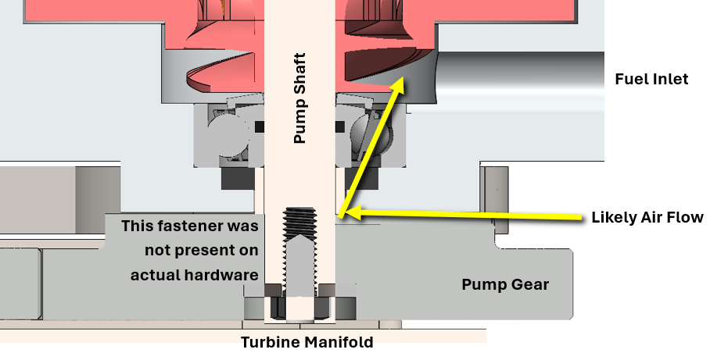

1. Fuel pump flow was almost nonexistent compared to lox pump. I am pretty sure this is because it was not properly sealed along its shaft, on the side close to the inlet and inducer. This is really the only relevant difference I can think of between the two pumps that could cause this. It could have been aspirating a lot of air into its inlet, more than water – maybe there was a high-pressure stream of air coming out the outlet but it’s impossible to know from the video.

My intent was to put packing seals in the pictured gap, but because it rests against the bearing it jammed the balls when I tried this; I was not able to rotate the shaft by hand at all. I opted to not put any seal at all here because of lack of time and naively hoping that the clearance between the shaft and hole was small enough to somewhat cc seal it. I knew water was going to leak out before the test started (which it did at a very slow dribble that doesn’t really affect anything), but I hadn’t thought about the fact that air would leak in during the test, in the opposite direction.

So that’s a simple design oversight – I’m thinking now I may be able to correct this by adding a small, specifically dimensioned washer of some kind that separates the bearing from the packing seals, and adding a packing seal back in. Or I may switch the open ball bearing to a sealed ball bearing and take the hit on max shaft RPM, especially since the real speed isn’t getting close anyways. This test *did* demonstrate that packing seals work (at least to some degree), because there was a packing seals separating the fuel and lox pumps. If they did not work then the lox pump would have been aspirating air from the fuel pump and had similarly anemic performance.

1. The first test spun great, overcoming any friction, but subsequent tests ground to a halt. We could hear (and verified from videos) that the turbine would begin spinning up for a few seconds at most and then slowed to a stop. After reapproaching, I would try to spin the turbine by hand and each time it would feel caught until I worked it around a little bit and it would start spinning freely again. Some parts (especially the gear and fuel pump casing) were slightly warmer than the other parts. To be clear, everything was quite cold from water splashing around and adiabatically expanded nitrogen gas flowing through the system (both the dome regs and nitrogen bottles were fully iced up on their surface), but those parts were close to more room temperature.

So I think it’s pretty clear the issue was a sudden spike in friction when it started spinning, and one that would not have appeared in the first test. In light of this I am pretty sure the issue is the pump gear sliding up along the shaft and coming in contact with the steel of the turbine manifold. A couple days ago I had angle grinded the pump shaft shorter and forgot to redrill and tap a bolt hole on its end which was to be used for the retention of that gear. So the gear was just friction fit axially onto the shaft (it still had a shaft key for rotation/torque so that wasn’t an issue). I didn’t fully remember this until integration was almost done, but I naively rationalized the fit was tight enough (I had to hammer it on originally, it was close to an interference fit probably) that I could leave it so I didn’t have to take it all apart and put back together (which can take hours sometimes). Last night I noticed what was originally a tight fit had gotten progressively looser from fiddling around with the system. So about an hour or so before the test, I was able to place some 5 minute epoxy on the shaft around both sides of the gear (using a 3/32” welding rod, that’s how thin the gap was). I think this epoxy job was enough for the first test to work. But because everything got quite cold and wet, the epoxy probably shattered and/or washed away at some point before the second test. Then the pump gear slid down the shaft during that test and the gear started rubbing on steel and brought the whole thing to a halt.

1. The rotation rate was way too low, so the whole system underperformed. Looking at the audio spectrum, there is a strong peak around 3750 Hz * 60 s/min * 40 blades/revolution = 5625 RPM; the target for turbine speed is 30,000 RPM (and pump speed should be 20,000 RPM). This is almost certainly mainly because the nitrogen flowrate was much too slow. Target was ~1000 SCFM, but a rough estimate of the actual rate would be 2 bottles * 230 SCF / ~2.5 min = 184 SCFM. Turbine speed is theoretically a linear function of gas mass flow, which completely tracks: 1017 SCFM / 184 SCFM * 5625 RPM = ~31000 RPM. So I think it is valid to say there is no speed problem with the turbopump itself, only the nitrogen feed to it.

I suspect the primary issue is the size of the orifice built into the bottle itself. I think it is possible a smaller effect might be a limitation of the dome reg when it gets quite cold; both regs were entirely iced up on their surface at the end of the test. I don’t think pressure loss through the feed system is a major issue because Alex did a test of this and there was very little difference between the supply reg pressure and the pressure downstream of the dome regs, and everything is a straight shot from there down to the manifold orifices without opportunity for significant losses.

## Second Spinflow Test (7/3/2024)

The second spinflow test was more successful than the first, but only marginally so. The fuel pump still has anemic flow. After this test is when I now think (as mentioned earlier in the report), that the larger issue with it, more than air leakage, is the direction of the incoming flow. The design has fluid impinging on the inducer from the side, which is then supposed to redirect it axially into the impeller. I no longer think it is able to effectively do this; rather the centrifugal acceleration is throwing back the incoming flow and starving the impeller of fluid.

Correcting this problem requires a significant design overhaul, because the geometric constraints of the current turbopump don’t allow an axial inlet onto the fuel impeller. The pump gear and turbine manifold are in the way. Further work on this will require me to redesign and remachine some parts. I do not know whether I will be doing this in the future or not, as I have now graduated and have much less time (understatement) to work on this.

But it was a lot of fun:

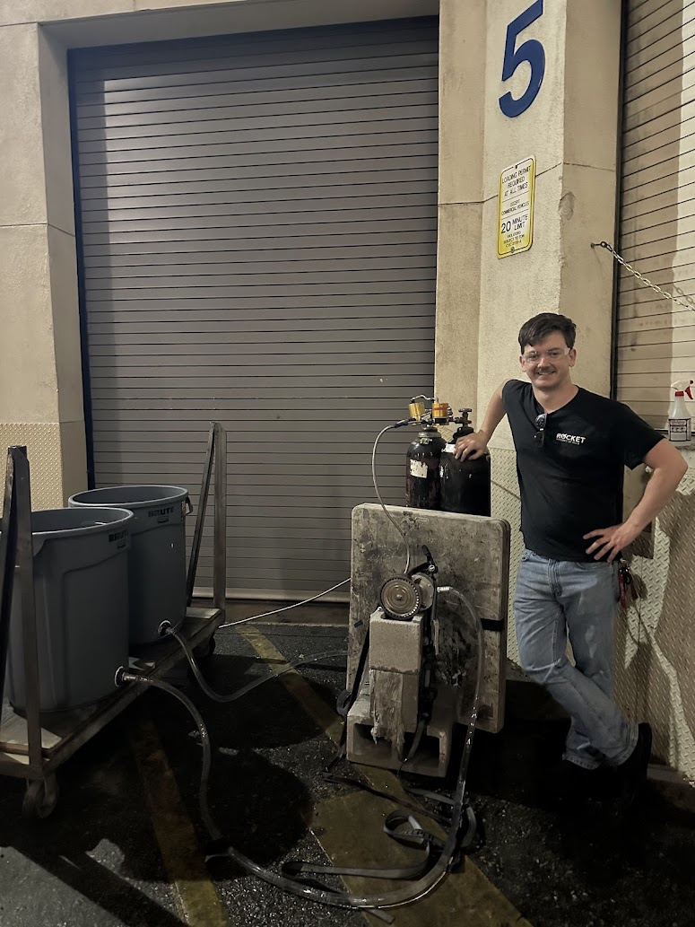

# Sourcing / Tools

McMaster-Carr

Industrial Metal Supply

Home Depot

KHK Gears

Craftcloud.com – 3DPnxt and Shenzhen 3D Innovate

UCLA Machine Shop

Rocket Project at UCLA

Pierce College Welding Shop

# Helpful People

Chris Cordova – CNC training, advice, scheduling

Alex Patrus – spinflow testing, feed system setup

Roni Margousi – feed system design and setup

Adam Kajganic – some machining help

Dave Crisalli – design advice

Mario Hernandez – design advice

# References

Karassik, I., Messina, J., Cooper, P., & Heald, C. (2008). *Pump Handbook.* McGraw-Hill.

NASA. (1971). *Liquid Rocket Engine Turbopump Inducers, SP-8052.*

NASA. (1973). *Liquid Rocket Engine Centrifugal Flow Turbopumps, SP-8109.*

NASA. (1974). *Liquid Rocket Engine Turbines, SP-8110.*

Also here’s me trying to cast impellers/inducers in the early days of the project. Don’t do this, the results were absolutely awful, go get these 3D printed lol (like I ultimately did through craftcloud.com).

